Ex.no:7b | DATA VISUALIZATION USING TABLEAU -  GLOBAL RENEWABLE ENERGY ANALYSIS

Aim
To connect, analyze, visualize, and create an interactive dashboard using the Global Renewable Energy and Indicators Dataset to analyze renewable energy production, installed capacity, investment, country-wise energy generation, energy-type distribution, renewable energy trends, and the factors influencing renewable energy development.
Software Requirements
• Tableau Desktop / Tableau Public
• Microsoft Excel
• CSV Dataset
• Windows Operating System
Theory
Power BI and Tableau are powerful Business Intelligence (BI) and Data Visualization tools used to create interactive dashboards and reports.
The Global Renewable Energy and Indicators Dataset contains information related to renewable energy production, installed capacity, investments, energy consumption, economic indicators, environmental indicators, and renewable energy development across different countries and years.
The dataset includes:
Country
Year
Energy Type
Production (GWh)
Installed Capacity (MW)
Investments (USD)
Population
Energy Consumption
GDP
CO2 Emissions
Proportion of Energy from Renewables
Renewable Energy Jobs
Policy-related indicators
Research and Development indicators
Other renewable energy and socioeconomic indicators
The dataset can be analyzed to identify renewable energy production trends, high-producing countries, energy-type contributions, investment patterns, installed capacity, and relationships between renewable energy development and economic or environmental indicators.

Tableau Architecture
Global Renewable Energy and Indicators Dataset
↓
Data Connection
↓
Data Cleaning and Preprocessing
↓
Power BI / Tableau
↓
Worksheets / Visualizations
↓
Interactive Dashboard
↓
Analysis and Insights

Sample Dataset
Global Renewable Energy and Indicators Dataset
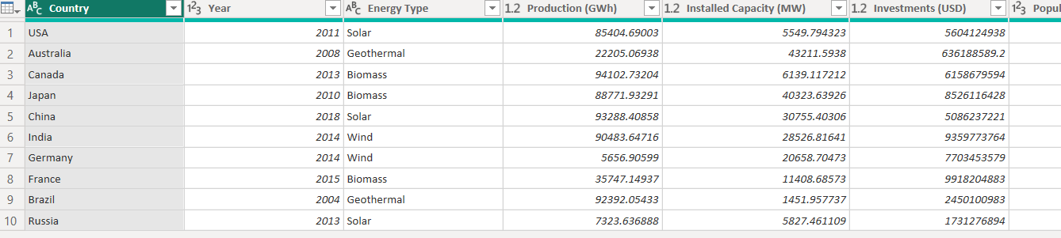

The actual dataset contains a larger number of records and columns.
Algorithm 1 – Connecting Data Source
Step 1
Open Tableau Desktop.
Step 2
Select Connect.
Step 3
Choose Microsoft Excel or Text File depending on the dataset format.
Step 4
Browse and select the Food Waste Prediction Dataset.
Step 5
Open the dataset.
Step 6
Verify the imported fields such as:
- City
- Cuisine
- Date
- Food Item
- Restaurant Name
- Customers
- Prepared Quantity
- Sold Quantity
- Remaining Quantity
- Waste Amount kg
- Waste Percentage

Procedure
Tableau
↓
Connect
↓
Excel / Text File
↓
Food Waste Prediction Dataset
↓
Open
↓
Verify Data

Output
Global Renewable Energy and Indicators Dataset loaded successfully into Power BI/Tableau.
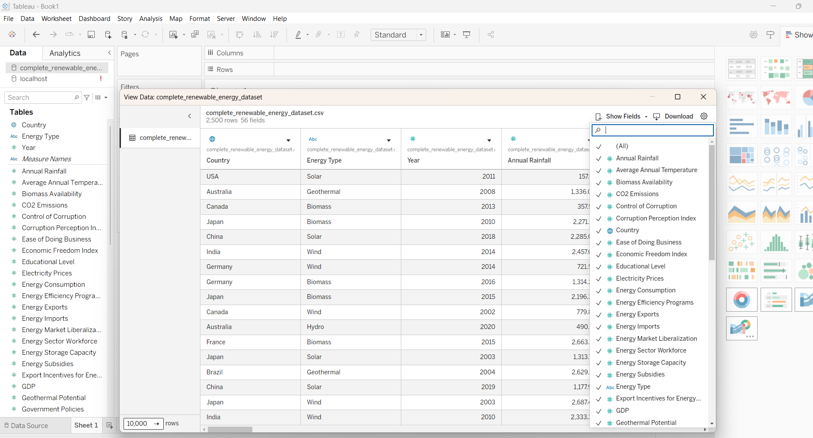
Algorithm 2 – Creating Worksheet
Objective

To evaluate and contrast clean power generation metrics across various nations.

Step 1

Access Sheet 1 or initialize a fresh reporting canvas.

Step 2

Pick the Bar Chart layout from available chart styles.

Step 3

In Power BI, assign Country into the vertical Y-axis field.

Step 4

Place Production (GWh) into the horizontal X-axis container.

Step 5

Set the aggregation type to Sum of Production (GWh).

Step 6

Arrange the country records in descending sequence according to Production (GWh) totals.

Step 7

Turn on Show Data Labels when necessary.

Step 8

Assign the header titled Renewable Energy Production by Country.

Output

Visual sheet generated with full success.

Interpretation

The bar chart illustrates overall sustainable power yields across diverse territories. It assists in benchmarking energy output totals and pointing out high-producing versus low-producing nations.
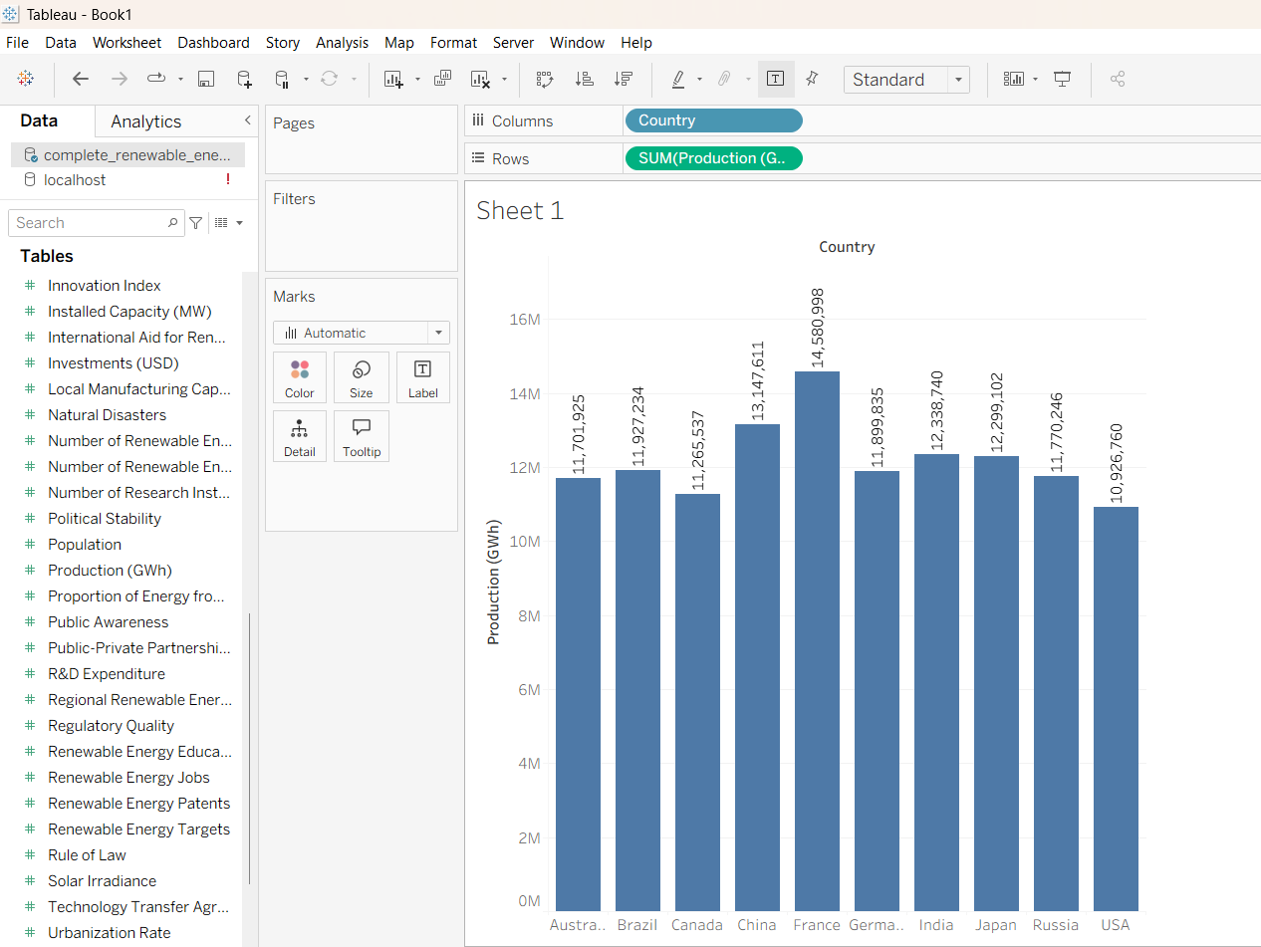

Algorithm 3 – Bar Chart Creation
Objective
To evaluate and contrast clean power generation metrics across various nations.
Step 1
In Power BI, assign Country into the vertical Y-axis field.
Step 2
Place Production (GWh) into the horizontal X-axis container.
Step 3
Select Bar Chart from Show Me.
Step 4
Enable Show Mark Labels.
Step 5
Sort the restaurants in descending order

Output Visualization
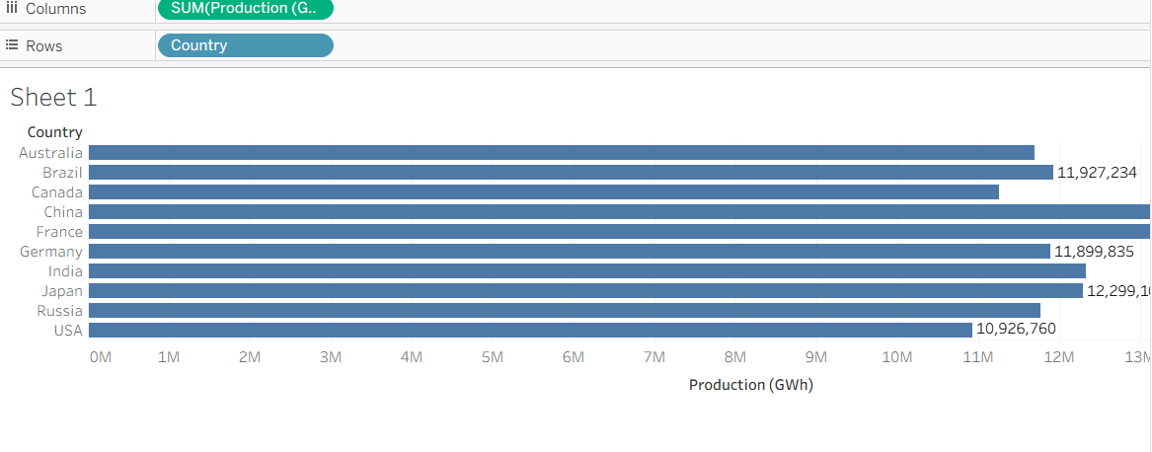
Interpretation
The bar chart illustrates overall sustainable power yields across diverse territories. It assists in benchmarking energy output totals and pointing out high-producing versus low-producing nations.
Algorithm 4 – Pie Chart Creation
Objective
To examine the proportion of clean power generation across various energy categories.
Step 1
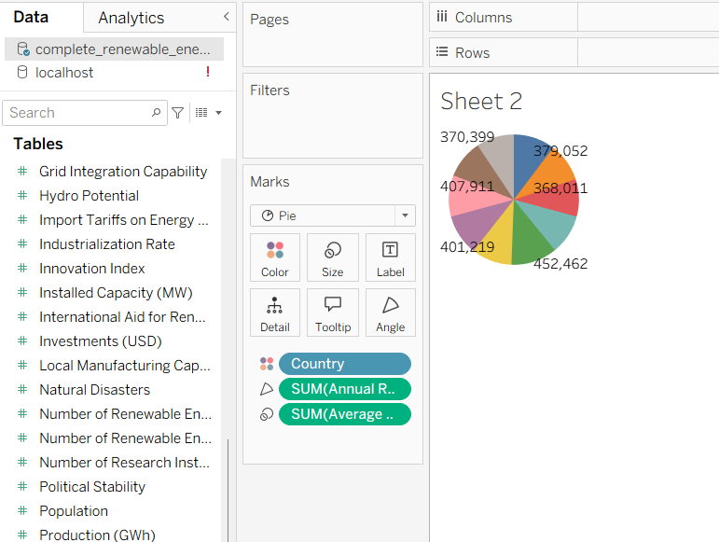

Interpretation
The pie chart illustrates the share of distinct clean power sources in overall renewable generation. It aids in pointing out primary energy categories driving sustainable power output.
Algorithm 5 – Line Chart Creation
Objective
To examine green energy generation trajectories across temporal dimensions.
Step 1
Position Year into the horizontal X-axis container.
Step 2
In Power BI, assign Production (GWh) into the vertical Y-axis field.
Step 3
Pick the Line Chart layout from available chart styles.
Step 4
Set the summary mode to Sum of Production (GWh).
Step 5
Turn on Show Data Labels when necessary.
Step 6
Evaluate clean power generation shifts across different annual periods.
Step 7
Assign the header titled Renewable Energy Production Trend Over Time.
Output Visualization
Renewable Energy Production Trend Over Time Line Chart
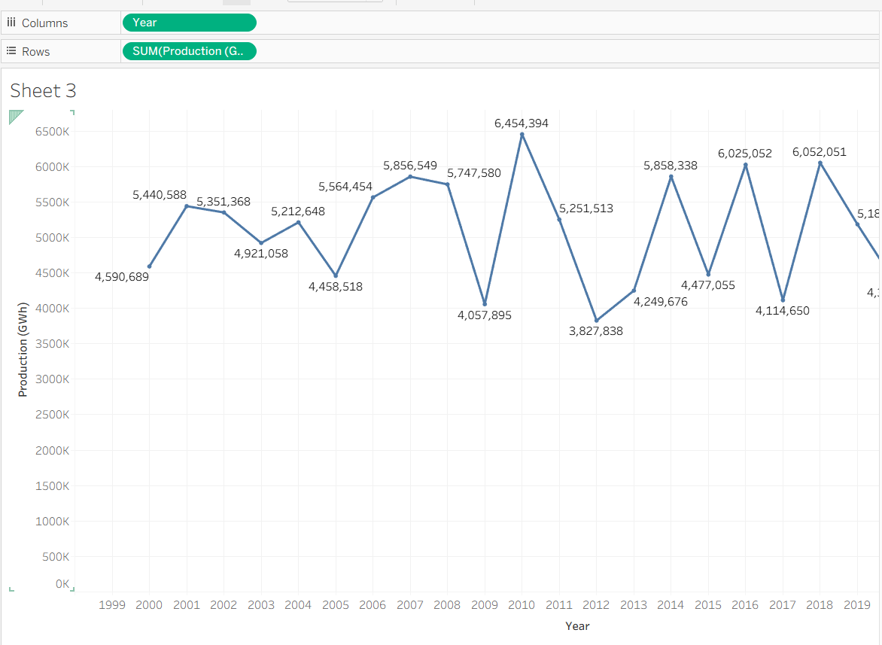
Interpretation
The line chart illustrates how clean power generation evolves across annual cycles. It aids in pointing out:
o Ascending output patterns
o Declining output patterns
o Maximum generation timeframes
o Minimum generation timeframes
o Fluctuations in sustainable power output

Algorithm 6 – Creating Calculated Field
Objective
To determine the mean ratio of power generated via sustainable resources.
Step 1
Navigate to Modeling and choose New Measure within Power BI.
Step 2
Provide the measure title:
Average Renewable Energy Percentage
Step 3
Type the DAX expression:
Average Renewable Energy Percentage =
AVERAGE('complete_renewable_energy_dataset (2)'[Proportion of Energy from Renewables])
Step 4
Press Enter to confirm.
Output
Average Renewable Energy Percentage
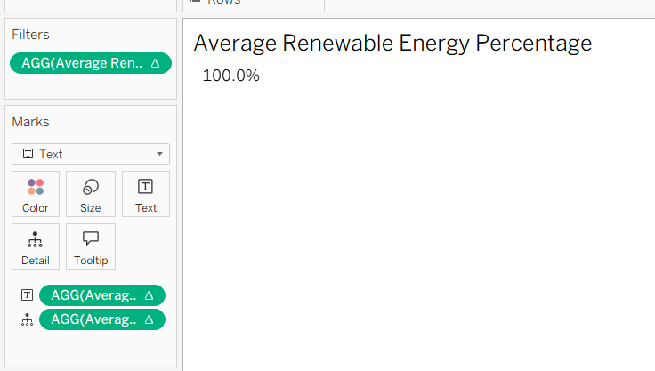
Interpretation
This custom metric evaluates the mean share of power derived from green resources. It aids in assessing the integration of clean generation across the grid infrastructure.

Algorithm 7 – Applying Filters
Objective
To examine green energy generation metrics for a designated nation.
Step 1
Position Country into the Filters or Slicer segment.
Step 2
Pick the target territory.
Step 3
Enable Show Filter when operating in Tableau.
Step 4
Specify an individual country like India.
Step 5
Review the refreshed graphic displays.
Step 6
Establish an additional filter or slicer utilizing Year.
Step 7
Choose a specific annual timeframe and observe variations across the dashboard visuals.
Example
Filter criteria: Country = India
Output
The reporting tools present sustainable power entries and output statistics corresponding to the chosen nation.
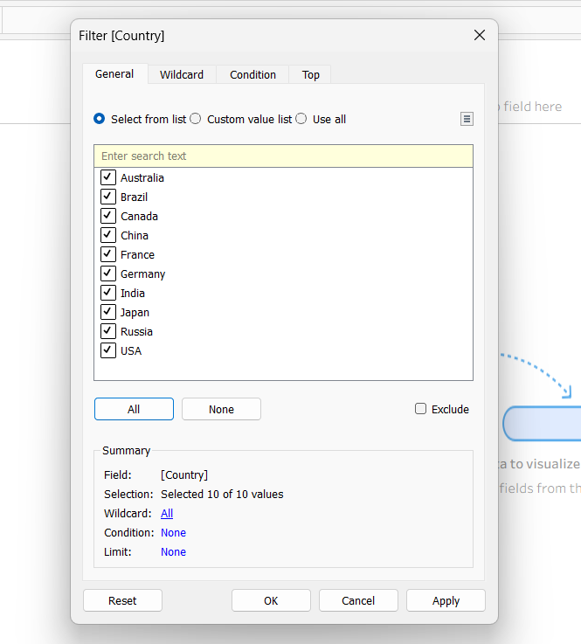
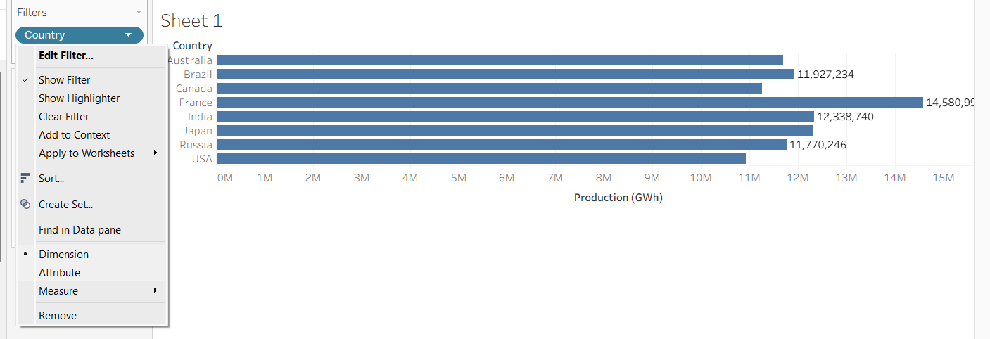
Interpretation
The Country filter enables analysts to isolate a single nation and conduct in-depth clean power evaluation.

Algorithm 8 – Creating Parameter
Objective
To filter and present nations interactively according to a specified threshold for green power generation.

Step 1

Establish a user control parameter or numerical criterion.

Step 2

Assign the variable identifier:

Minimum Production (GWh)

Step 3

Define the variable type as:

Floating Point / Fractional Number

Step 4

Input the target minimum generation level.

Step 5

Construct a custom field expression or logical filter using this parameter.

Expression

[Production (GWh)] &gt;= [Minimum Production (GWh)]

Case Instance

Selected Threshold = 50000 GWh

Output

The chart updates to reveal entries where total sustainable power generation equals or surpasses the set cutoff.

Interpretation

This variable control allows analysts to isolate major sustainable power producers seamlessly by adjusting a customized cutoff point.

Algorithm 9 – Dashboard Creation
Onjective:
To construct an interactive reporting interface for comprehensive green power evaluation.
Step 1
Build various reporting worksheets and graphics.
Step 2
Open a fresh summary canvas or report view.
Step 3
Import the designated visual sheets into the canvas space.
Step 4
Position the generated graphics systematically.
Step 5
Set up key metrics displays for:
o Overall Sustainable Power Yield
o Overall System Capacity
o Cumulative Capital Allocation
o Total Participating Nations
Step 6
Integrate the following graphical displays:
o Annual Generation Trajectory – Line Chart
o Top Ten Countries by Output – Bar Chart
o Output Distribution by Energy Classification – Pie Chart
o Capital Funding vs Generation Volume – Scatter Plot
Step 7
Embed interactive controls for:
o Territory Selection
o Annual Timeframe
o Clean Energy Classification
Step 8
Incorporate suitable headers and descriptive labels.
Step 9
Format the layout structuredly for optimal user accessibility.
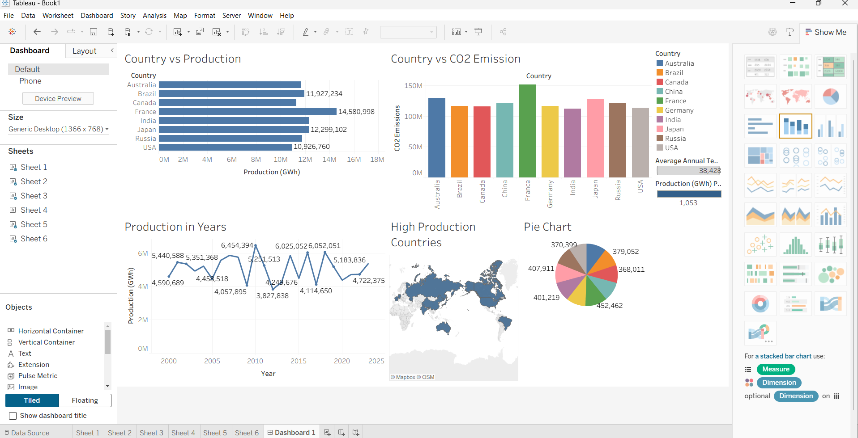
Interpretation
The canvas presents a unified perspective on sustainable power generation, system capacity, capital investments, territorial outputs, category breakdowns, and temporal trajectories. It facilitates interactive exploration using filters and integrated graphical components.

Algorithm 10 – Story Creation
Objective
To present the sequential visual synthesis of sustainable power yields, national results, generation categories, financial investments, and clean energy trajectories.

Step 1

Construct all necessary visual worksheets.

Step 2

Build the Global Renewable Energy Analysis Dashboard.

Step 3

Select Story → New Story inside Tableau.

Step 4

Integrate the primary dashboard alongside selected worksheets into distinct story points.

Step 5

Order every story point in a structured narrative progression.

Step 6

Deliver the analytical conclusions.

Example Story Story Point 1
Overall Renewable Energy Analysis

Summarizes aggregate clean energy generation, overall installed power capacity, cumulative financial capital, and the count of participating territories.

Story Point 2

Renewable Energy Production Trend

Illustrates temporal shifts in green power generation throughout consecutive annual spans.

Story Point 3

Country-wise Renewable Energy Analysis

Contrasts sustainable generation volume across distinct global territories.

Story Point 4

Energy Type-wise Analysis

Details the proportional share contributed by separate sustainable fuel classifications toward total output.

Story Point 5

Investment and Production Analysis
Evaluates the interrelationship joining capital funding and resulting green energy yields.

Story Point 6

Final Renewable Energy Analysis

Synthesizes key trends and analytical discoveries derived throughout the dataset processing.

Applications

Renewable Energy Planning

Strategic evaluation concerning power output, installed infrastructure, and monetary investments to guide sector development.

Energy Policy Analysis

Location of nations and specific clean resource categories with accelerated expansion to optimize legislative frameworks.

Investment Analysis

Assessment of capital deployed into green infrastructure and its direct impact on power generation capacity.

Environmental Analysis

Investigation linking clean power deployment with ecological metrics, including carbon dioxide discharge levels.

Country-wise Comparison

Cross-territorial bench-marking of generation volume and installed sustainable system capabilities.

Energy Management

Examination covering generation and consumption behavior to enhance grid resource management strategies.

Business Intelligence

Dynamic visual reporting and dashboard-driven analysis focused on green energy performance.

Decision Making

Pinpointing top-tier countries, critical resource categories, and key sector dynamics to assist executive planning.

Sustainability Analysis

Tracking sustainable energy expansion while identifying possibilities to elevate clean generation utilization.

Data Analytics

Interactive visualization, exploratory analysis, and interpretation of global renewable energy patterns.

Result

